**CSS GRID**

**Oleh:** Sutrisno Sukarno, M.Kom

**Referensi:**

* <https://www.w3schools.com/css/css_grid.asp>

**Materi yang harus sudah dikuasai:**

* HTML Dasar
* CSS Dasar
* Flex Box

1. **Contoh Grid Layout**

Koding dari Layout di atas menggunakan display Grid, buat file dengan nama grid1.html

<!DOCTYPE html>

<html>

<head>

<style>

.item1 { grid-area: header; }

.item2 { grid-area: menu; }

.item3 { grid-area: main; }

.item4 { grid-area: right; }

.item5 { grid-area: footer; }

.grid-container {

  display: grid;

  grid-template-areas:

    'header header header header header header'

    'menu main main main right right'

    'menu footer footer footer footer footer';

  gap: 10px;

  background-color: #2196F3;

  padding: 10px;

}

.grid-container > div {

  background-color: rgba(255, 255, 255, 0.8);

  text-align: center;

  padding: 20px;

  font-size: 30px;

}

#tengah {

    text-align: center;

}

</style>

</head>

<body>

<h1 id="tengah">Latihan CSS Grid 1 - Universitas Safin Pati</h1>

<p>CSS Grid Module adalah sistem tata letak berbasis grid, dengan baris dan kolom, sehingga memudahkan mendesain halaman web tanpa harus menggunakan float dan positioning.</p>

<div class="grid-container">

  <div class="item1">Header</div>

  <div class="item2">Menu</div>

  <div class="item3">Main</div>

  <div class="item4">Right</div>

  <div class="item5">Footer</div>

</div>

</body>

</html>

1. **Grid Layout**

CSS Grid Module adalah sistem tata letak berbasis grid, dengan baris dan kolom, sehingga memudahkan mendesain halaman web tanpa harus menggunakan float dan positioning.

1. **Browser Support**

Properti CSS Grid sudah support di semua browser terkini.

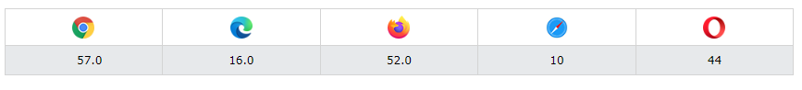

1. **Grid Elemen**

Layout Grid terdiri dari elemen induk dengan satu atau lebih elemen turunannya.

Display:Grid;

Latihan grid2.html

<!DOCTYPE html>

<html>

<head>

<style>

.grid-container {

  display: grid;

  grid-template-columns:  auto auto auto;

  background-color: #2196F3;

  padding: 20px;

}

.grid-item {

  background-color: rgba(255, 255, 255, 0.8);

  border: 1px solid rgba(0, 0, 0, 0.8);

  padding: 20px;

  font-size: 30px;

  text-align: center;

}

</style>

</head>

<body>

<h1>display: grid</h1>

<p>Use display: grid; to make a block-level grid container:</p>

<div class="grid-container">

  <div class="grid-item">1</div>

  <div class="grid-item">2</div>

  <div class="grid-item">3</div>

  <div class="grid-item">4</div>

  <div class="grid-item">5</div>

  <div class="grid-item">6</div>

  <div class="grid-item">7</div>

  <div class="grid-item">8</div>

  <div class="grid-item">9</div>

</div>

</body>

</html>

**Result:**

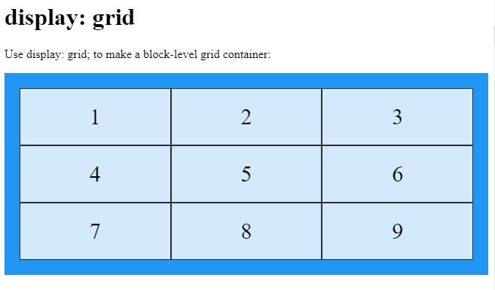

Display:Inline-grid;

<!DOCTYPE html>

<html>

<head>

<style>

.grid-container {

  display: inline-grid;

  grid-template-columns:  auto auto auto;

  background-color: #2196F3;

  padding: 20px;

}

.grid-item {

  background-color: rgba(255, 255, 255, 0.8);

  border: 1px solid rgba(0, 0, 0, 0.8);

  padding: 20px;

  font-size: 30px;

  text-align: center;

}

</style>

</head>

<body>

<h1>display: inline-grid</h1>

<p>Use display: grid; sesuai dengan konten yang ada di dalam item</p>

<div class="grid-container">

  <div class="grid-item">1</div>

  <div class="grid-item">2</div>

  <div class="grid-item">3</div>

  <div class="grid-item">4</div>

  <div class="grid-item">5</div>

  <div class="grid-item">6</div>

  <div class="grid-item">7</div>

  <div class="grid-item">8</div>

  <div class="grid-item">9</div>

</div>

</body>

</html>

Result:

Grid Columns

The vertical lines of grid items are called *columns*.

Grid Rows

The horizontal lines of grid items are called *rows*.

Grid Gaps

The spaces between each column/row are called *gaps*.

You can adjust the gap size by using one of the following properties:

* column-gap
* row-gap
* gap

Contoh column-gap.html

<!DOCTYPE html>

<html>

<head>

<style>

.grid-container {

  display: grid;

  column-gap: 50px;

  grid-template-columns: auto auto auto;

  background-color: #2196F3;

  padding: 10px;

}

.grid-item {

  background-color: rgba(255, 255, 255, 0.8);

  border: 1px solid rgba(0, 0, 0, 0.8);

  padding: 20px;

  font-size: 30px;

  text-align: center;

}

</style>

</head>

<body>

<h1>The column-gap Property</h1>

<p>Use the <em>column-gap</em> property to adjust the space between the columns:</p>

<div class="grid-container">

  <div class="grid-item">1</div>

  <div class="grid-item">2</div>

  <div class="grid-item">3</div>

  <div class="grid-item">4</div>

  <div class="grid-item">5</div>

  <div class="grid-item">6</div>

  <div class="grid-item">7</div>

  <div class="grid-item">8</div>

  <div class="grid-item">9</div>

</div>

</body>

</html>

Result colum-gap.html

Contoh row-gap.html

<!DOCTYPE html>

<html>

<head>

<style>

.grid-container {

  display: grid;

  row-gap: 50px;

  grid-template-columns: auto auto auto;

  background-color: #2196F3;

  padding: 10px;

}

.grid-item {

  background-color: rgba(255, 255, 255, 0.8);

  border: 1px solid rgba(0, 0, 0, 0.8);

  padding: 20px;

  font-size: 30px;

  text-align: center;

}

</style>

</head>

<body>

<h1>The row-gap Property</h1>

<p>Use the <em>row-gap</em> property to adjust the space between the rows:</p>

<div class="grid-container">

  <div class="grid-item">1</div>

  <div class="grid-item">2</div>

  <div class="grid-item">3</div>

  <div class="grid-item">4</div>

  <div class="grid-item">5</div>

  <div class="grid-item">6</div>

  <div class="grid-item">7</div>

  <div class="grid-item">8</div>

  <div class="grid-item">9</div>

</div>

</body>

</html>

Hasil di browser:

Gap.html

<!DOCTYPE html>

<html>

<head>

<style>

.grid-container {

  display: grid;

  gap: 100px 10px;

  grid-template-columns: auto auto auto;

  background-color: #2196F3;

  padding: 10px;

}

.grid-item {

  background-color: rgba(255, 255, 255, 0.8);

  border: 1px solid rgba(0, 0, 0, 0.8);

  padding: 20px;

  font-size: 30px;

  text-align: center;

}

</style>

</head>

<body>

<h1>The gap Property</h1>

<p>Use the <em>gap</em> shorthand property to adjust the space between the columns and rows.</p>

<div class="grid-container">

  <div class="grid-item">1</div>

  <div class="grid-item">2</div>

  <div class="grid-item">3</div>

  <div class="grid-item">4</div>

  <div class="grid-item">5</div>

  <div class="grid-item">6</div>

  <div class="grid-item">7</div>

  <div class="grid-item">8</div>

  <div class="grid-item">9</div>

</div>

</body>

</html>

Result:

Ok materi selanjutnya bisa di lihat di:

<https://www.w3schools.com/css/css_grid_container.asp>

<https://www.w3schools.com/css/css_grid_item.asp>

Silahkan di pelajari, di praktekan dan di ulang ulang

Semoga sukses